**Capstone**

**My Movie Plan Project**

**ScreenShots**

**First we will run the Project locally then we will deploy the code in aws EC2 Instance Using git and docker**

**Running the Backend SpringBoot Application**

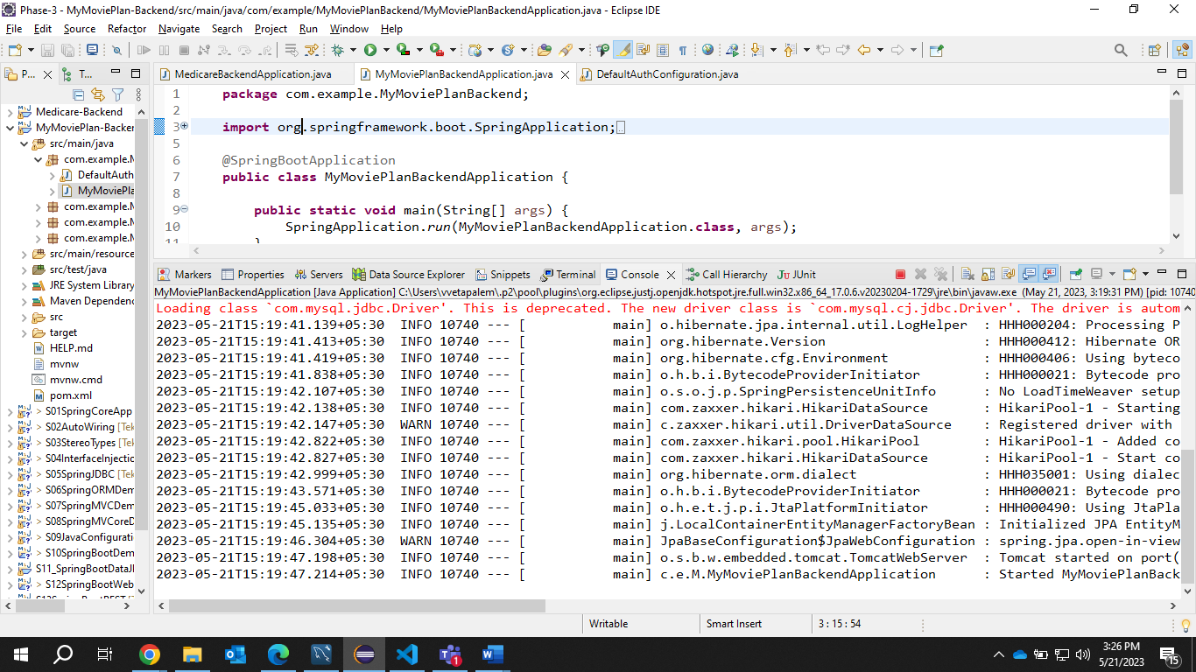

**Running the FrontEnd React js Application**

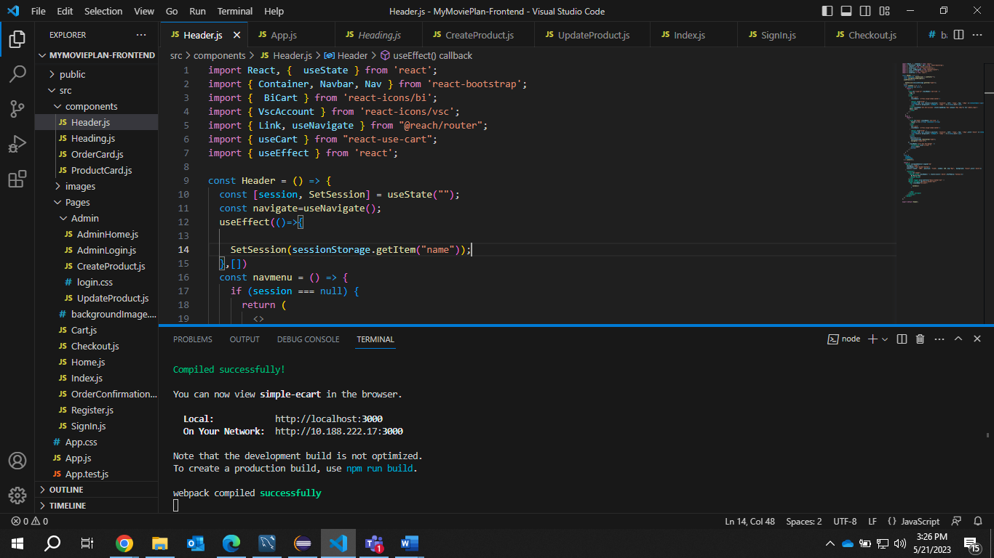

**Application Running on Localhost**

**Index.js**

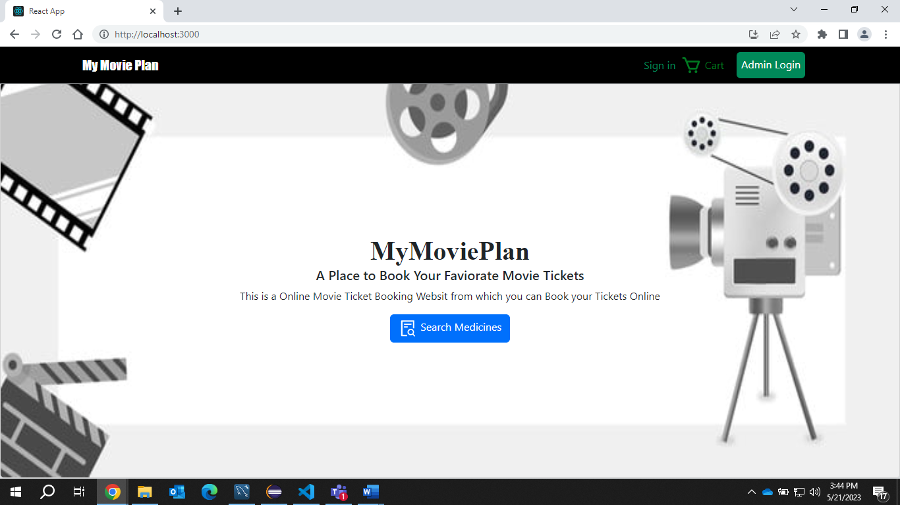

**Responsive**

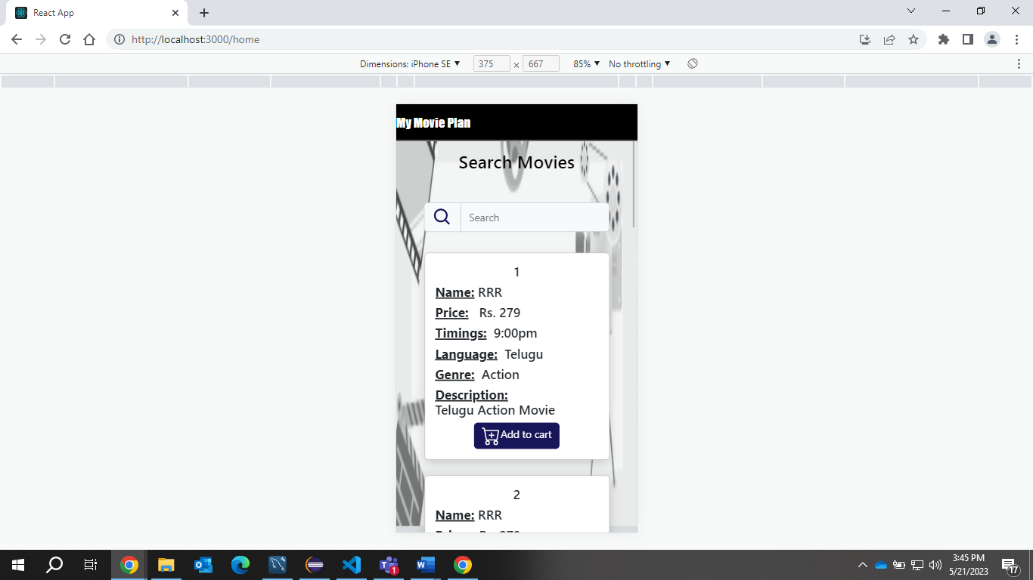

**Add items to cart**

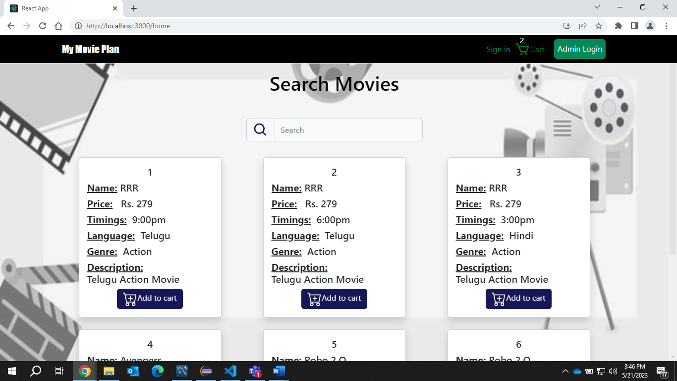

**Even With out sign in we can add the items to cart and that data will be stored in Localstorage**

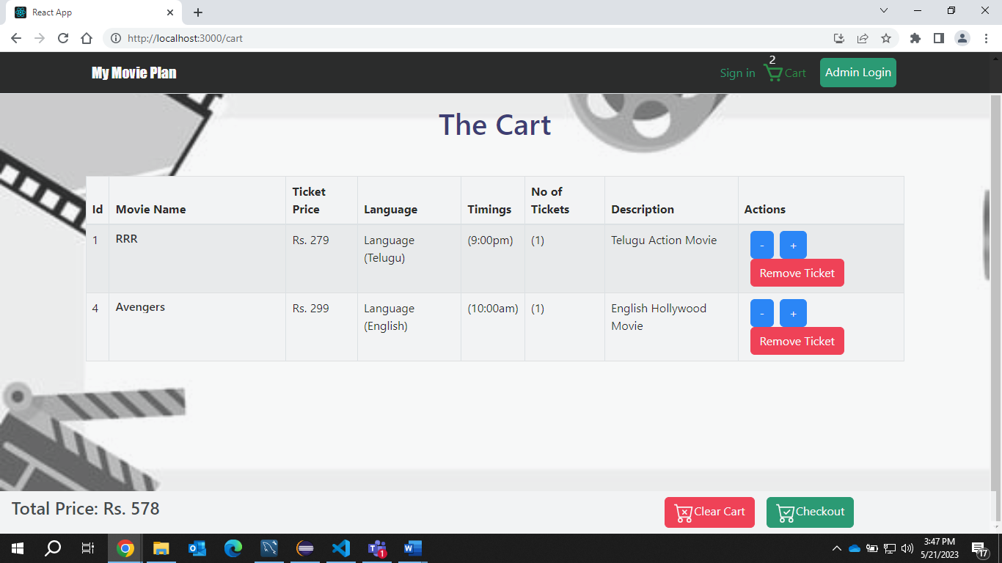

**As soon as we Click Checkout it will redirect to sign in page because user didn’t sign in**

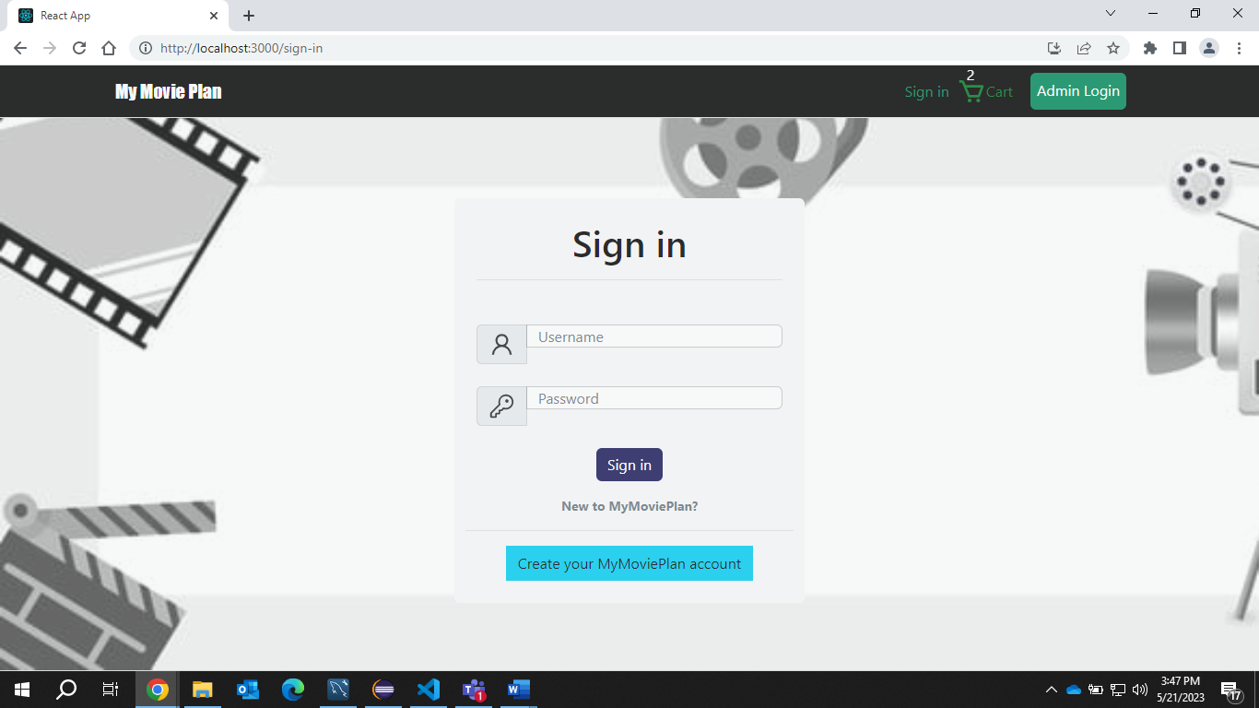

**Creating a User Account**

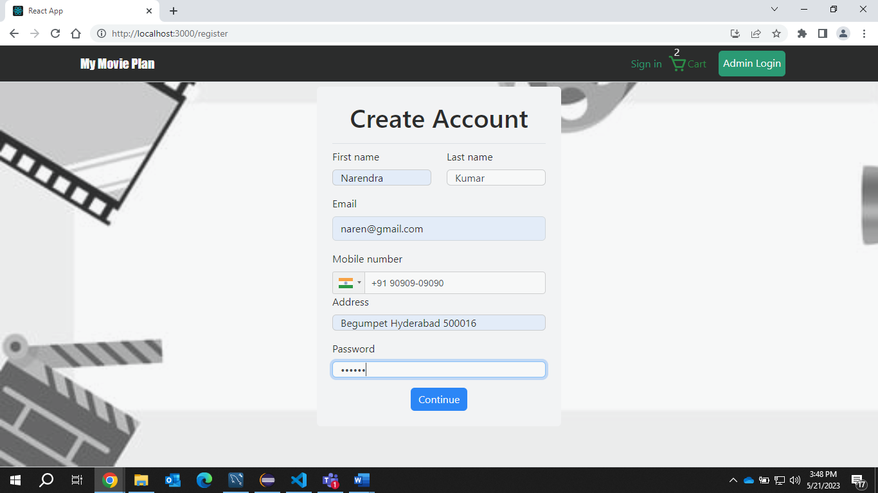

**Signing in**

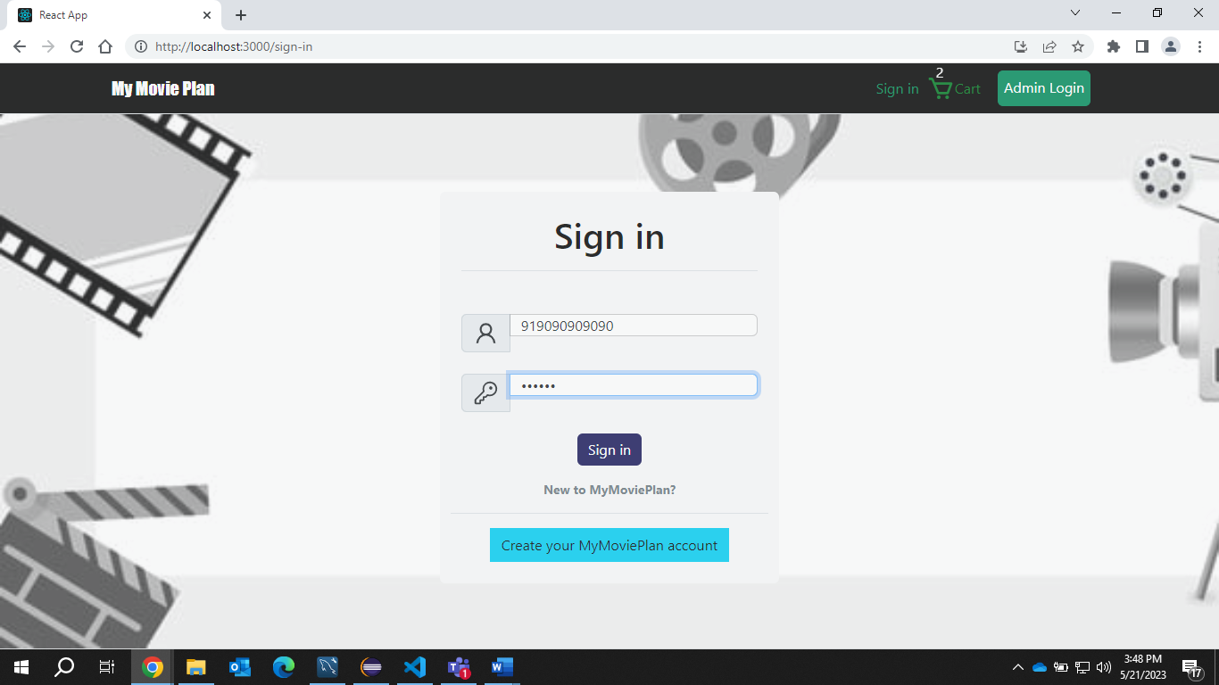

**As you can see the cart items are still there**

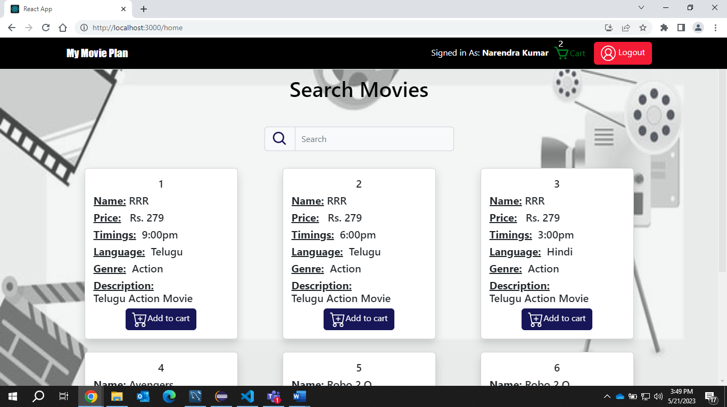

**Now if we Click Checkout this page will be display all the user Details will be pre-filled from the localStorage (Stored during Sign in)**

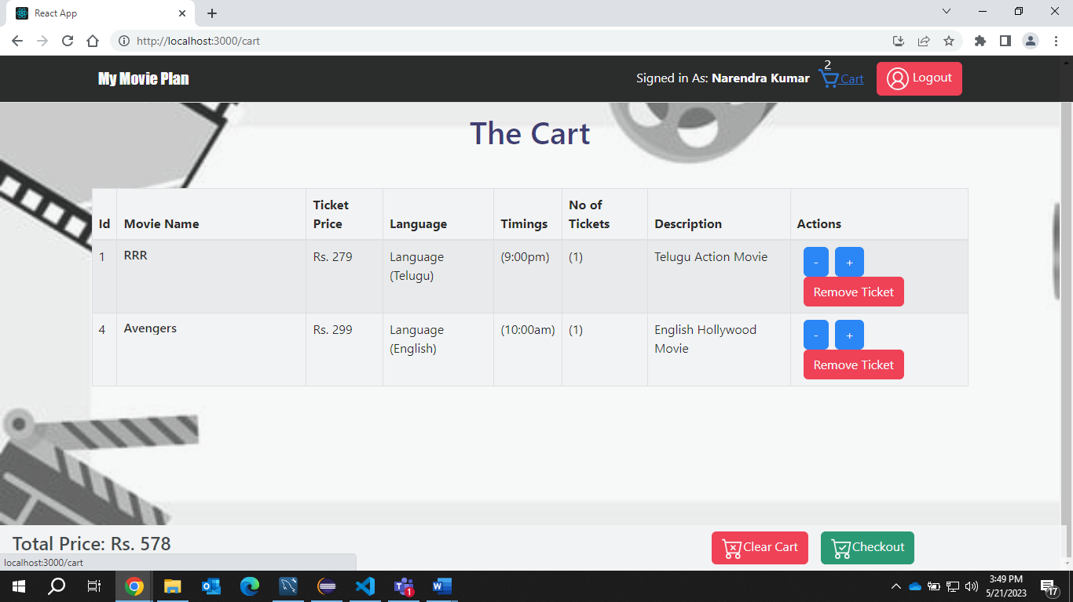

**Select the mode of Payment**

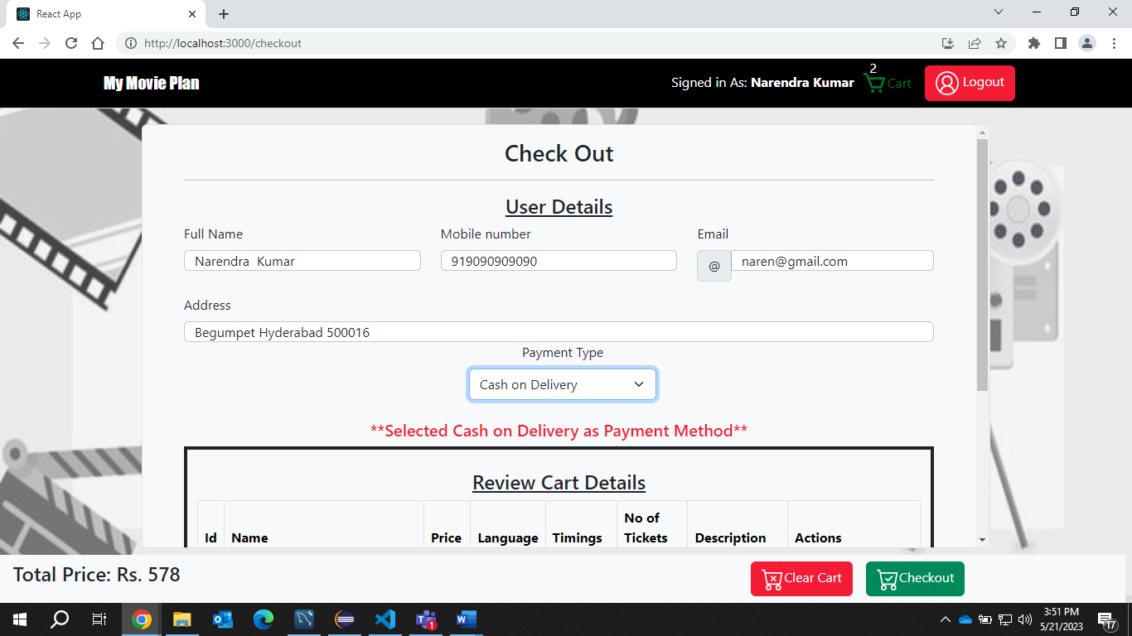

**Order Summary Page**

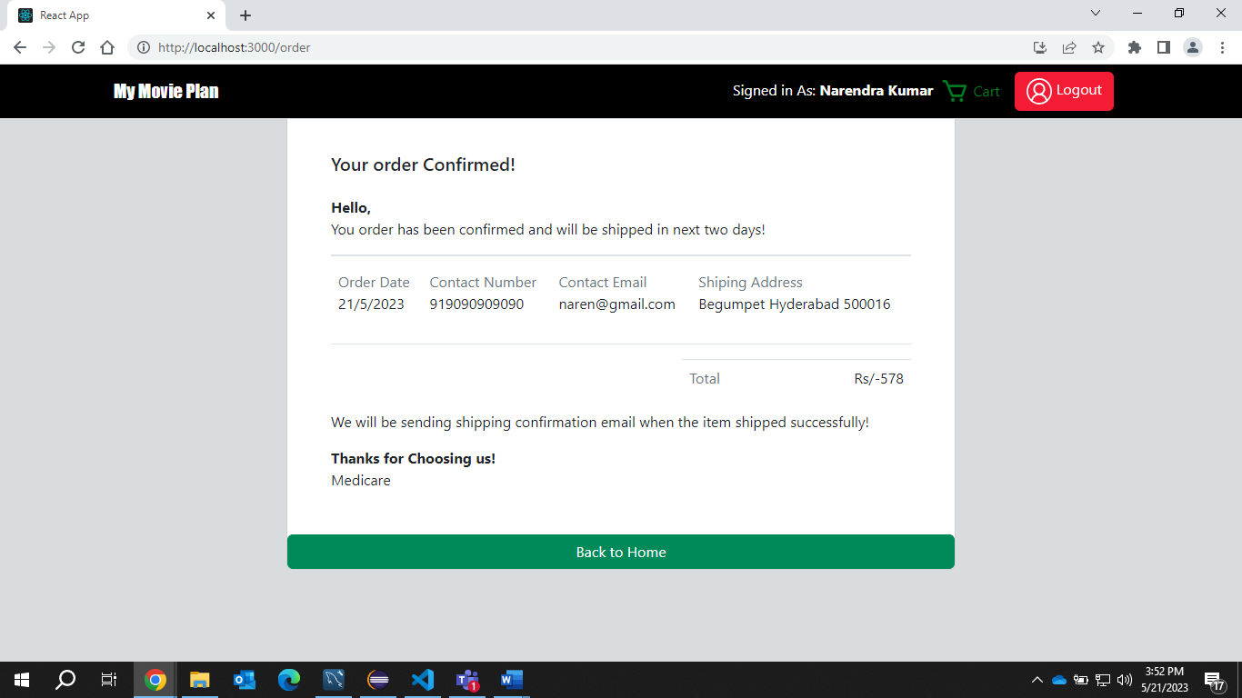

**Now cart will be empty ,Now go to admin Login**

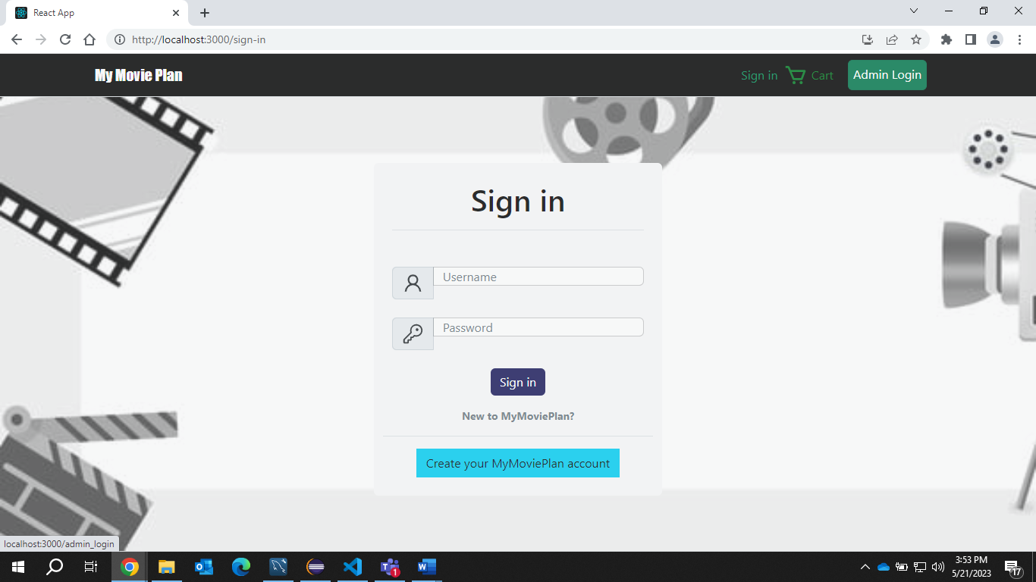

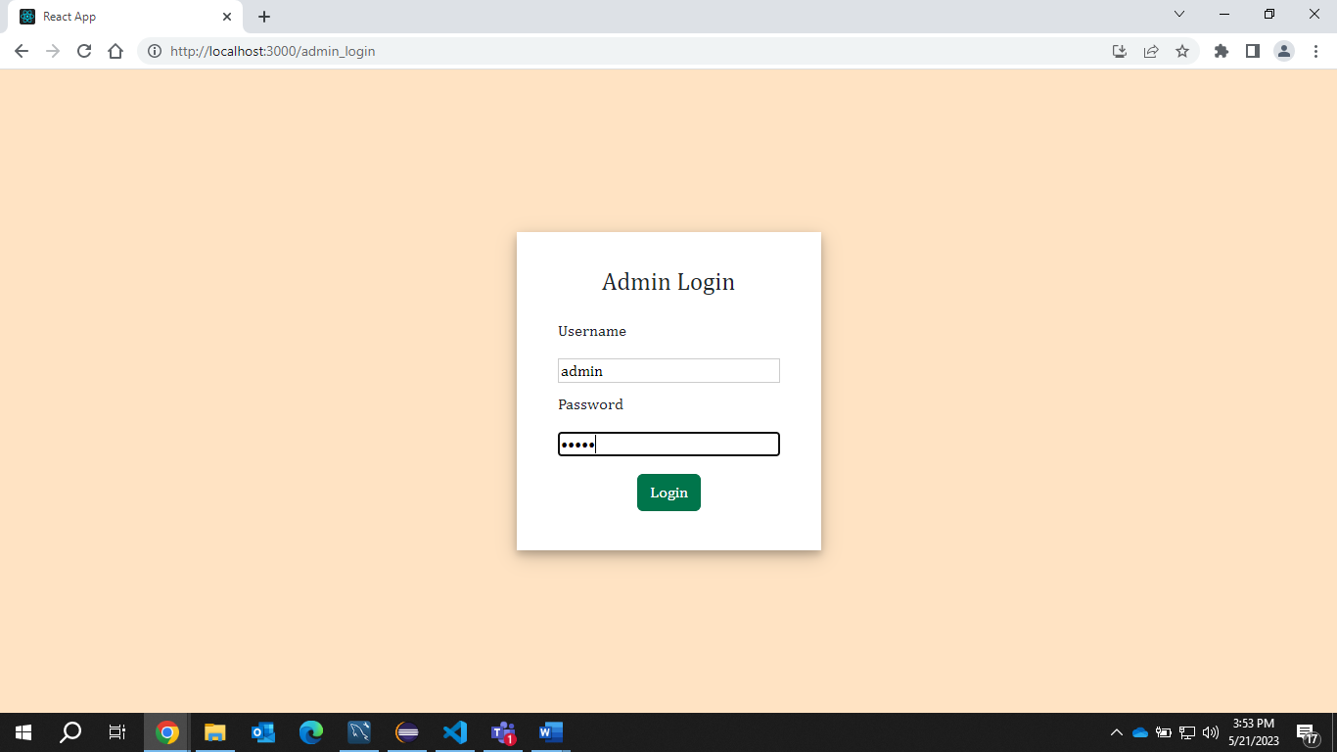 **We can see 6 records now we will add some data**

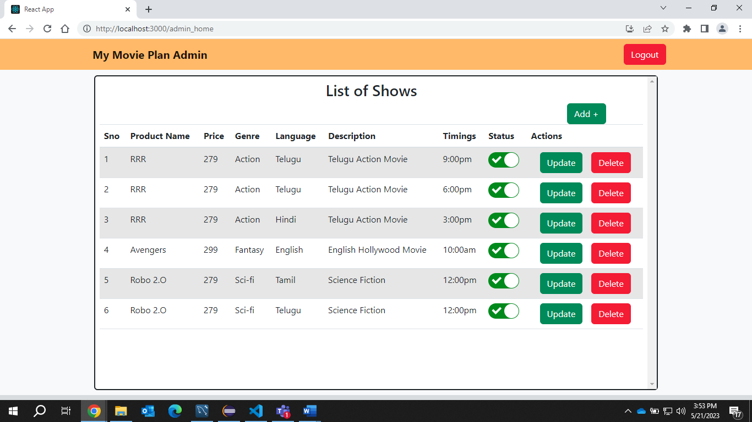

**Adding sample data**

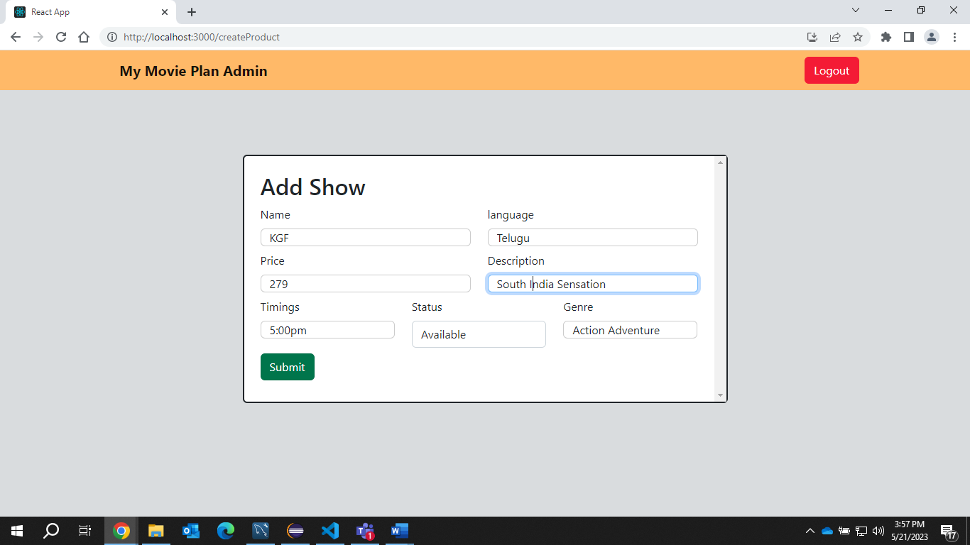

**As you can see Data is added**

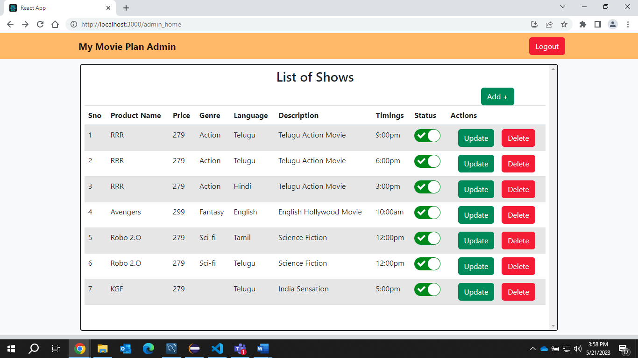

**Updating 1st item**

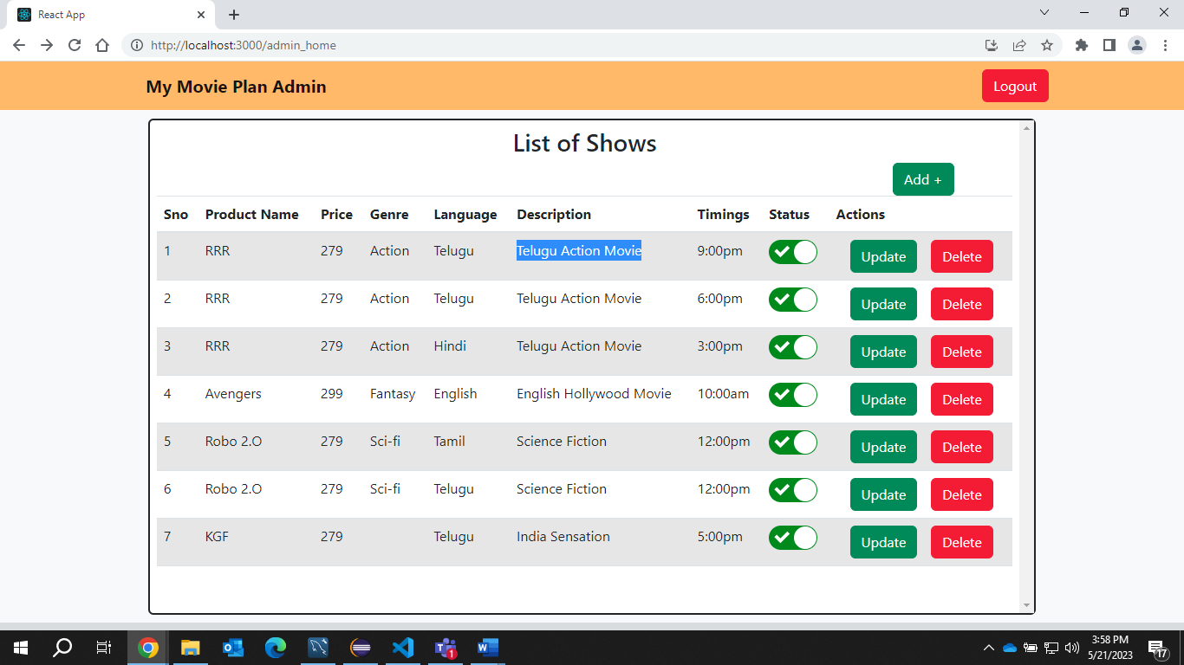

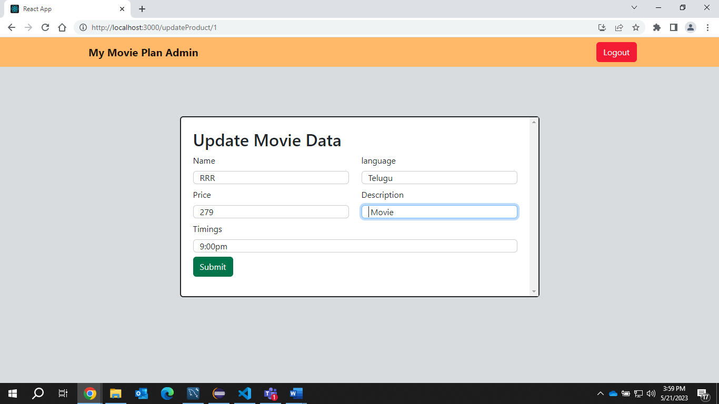

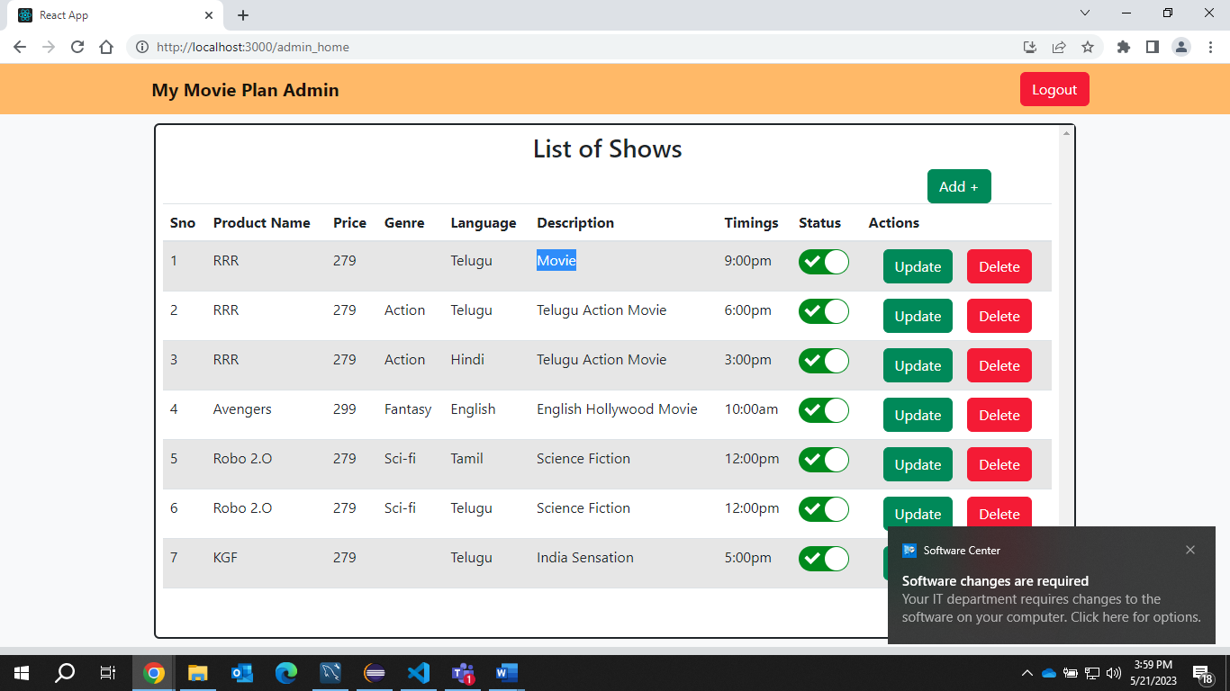

**As you can all the shows are set to available so all the data is displayed for the user**

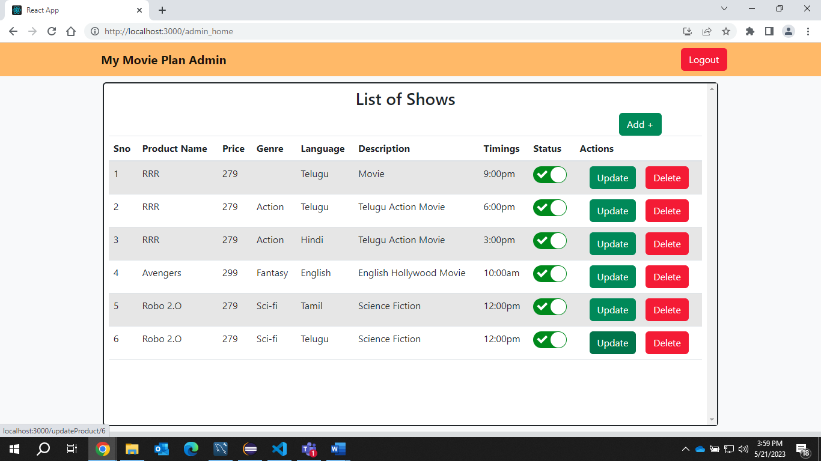

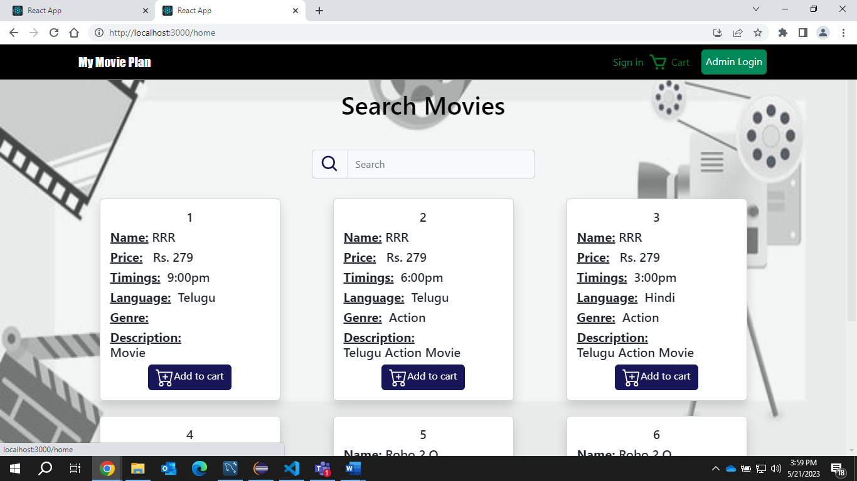

If I toggle 1st and 2nd show

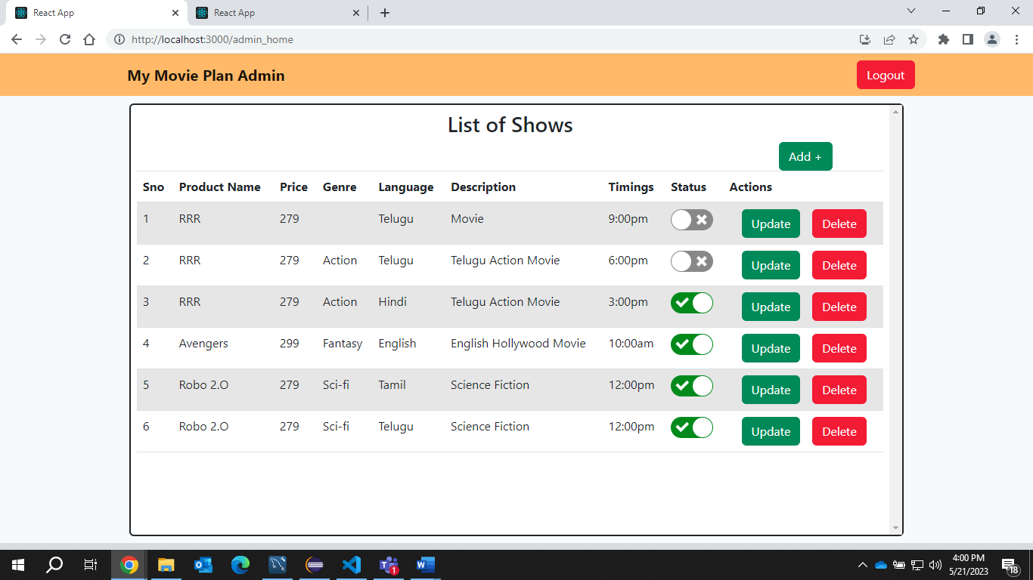

It wont be visible to user

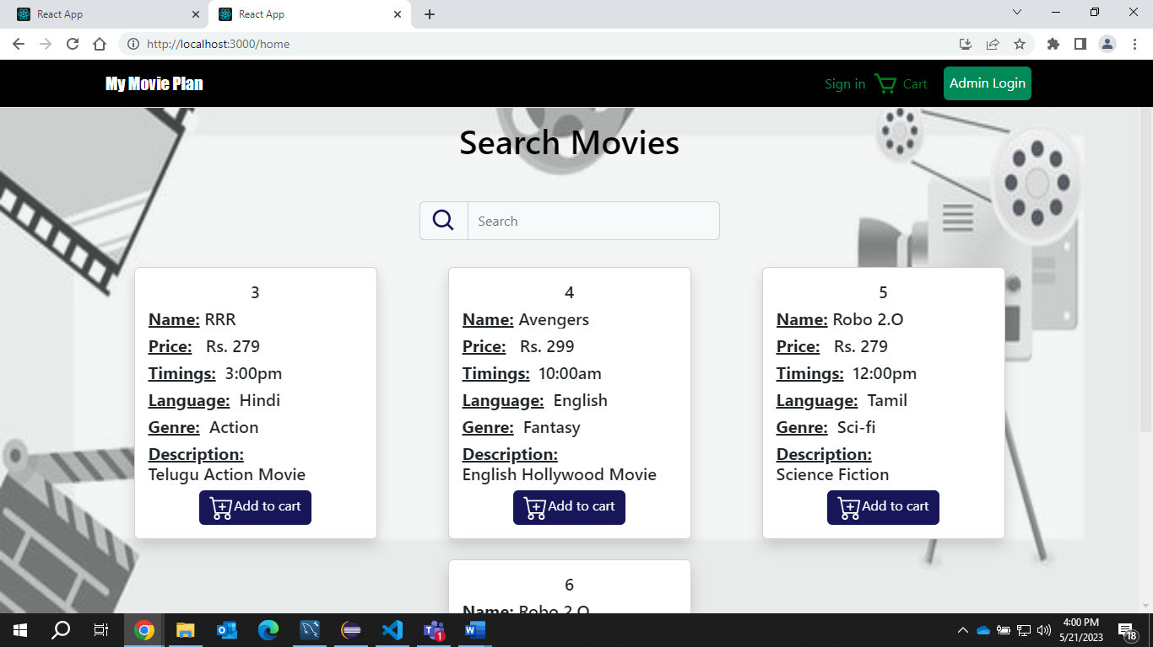

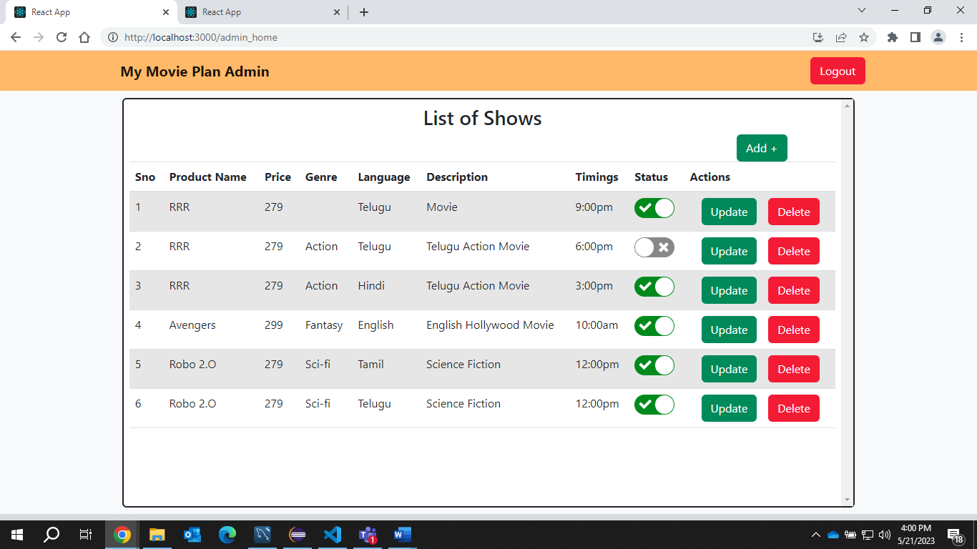

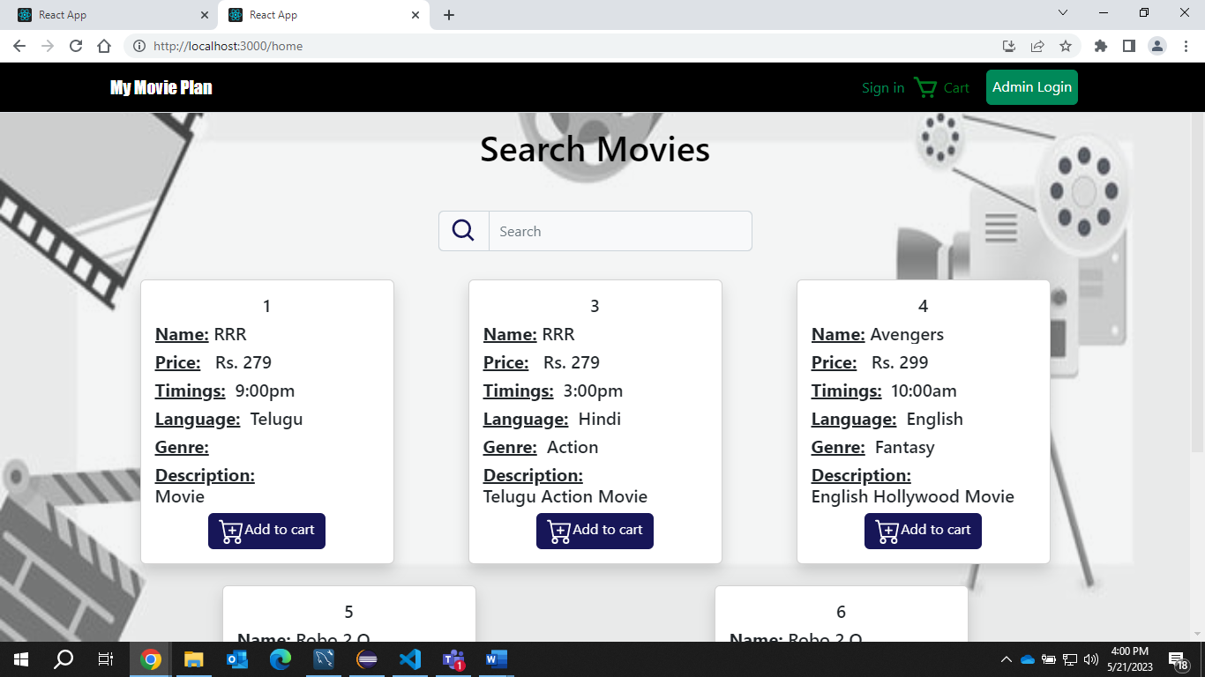

**Now we will Deploy our Project in Aws EC2**

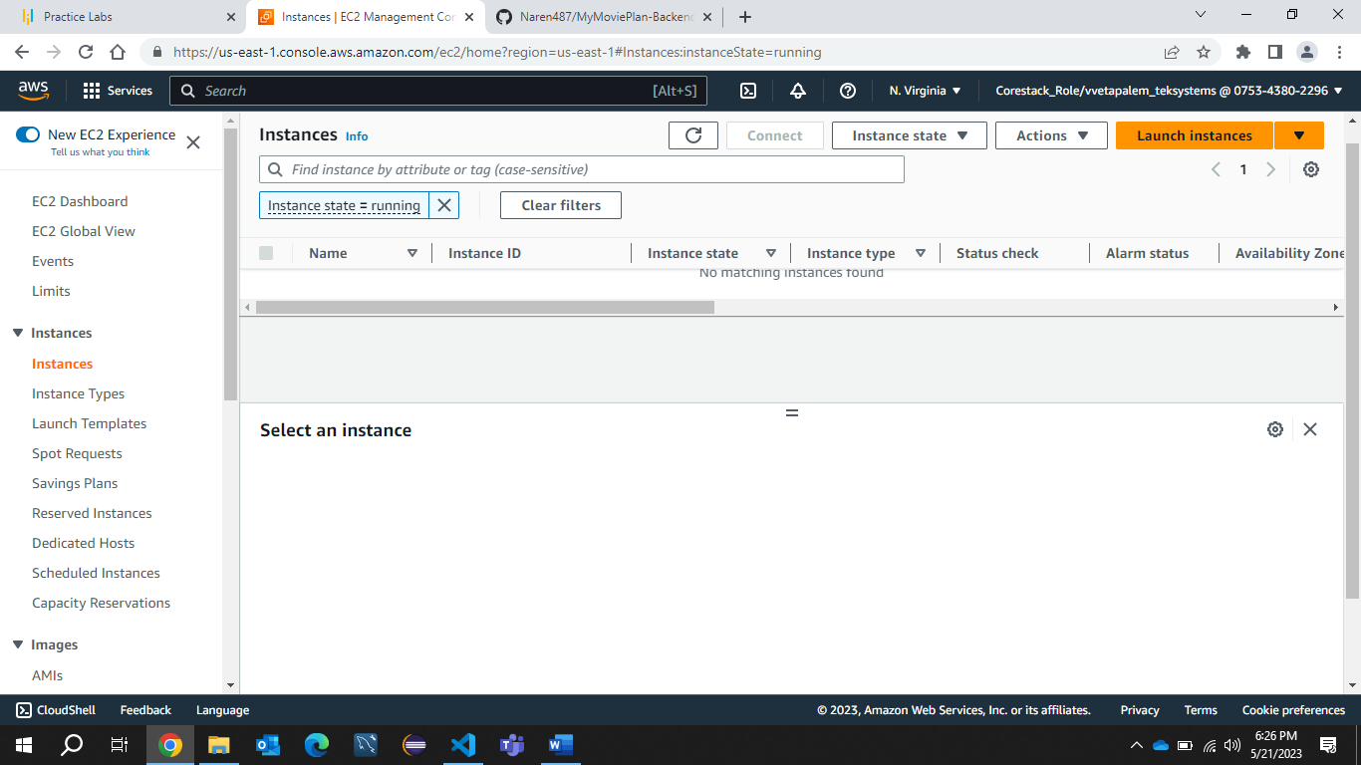

**Creating a instance for running Mysql**

**Installing Docker**

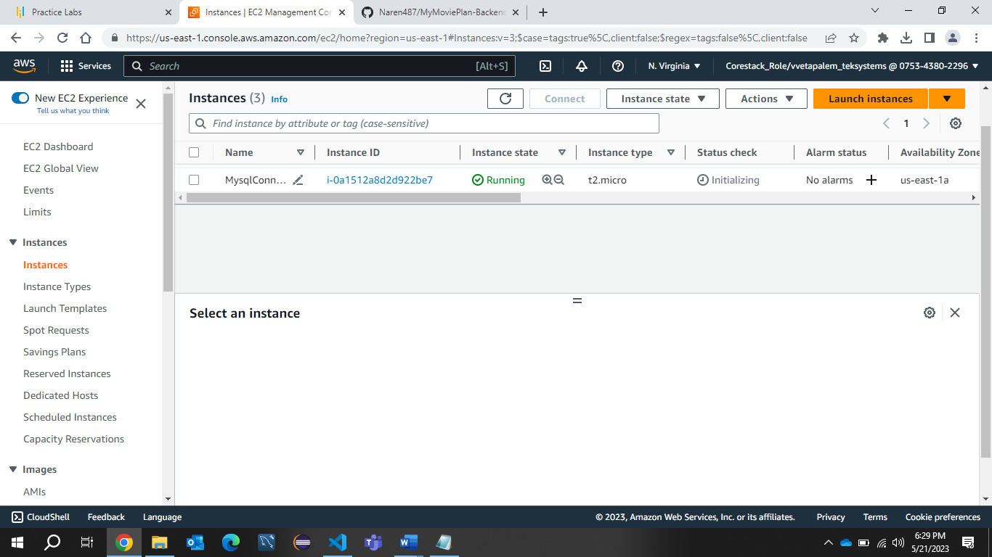

**Adding 3306 port for mysql instance**

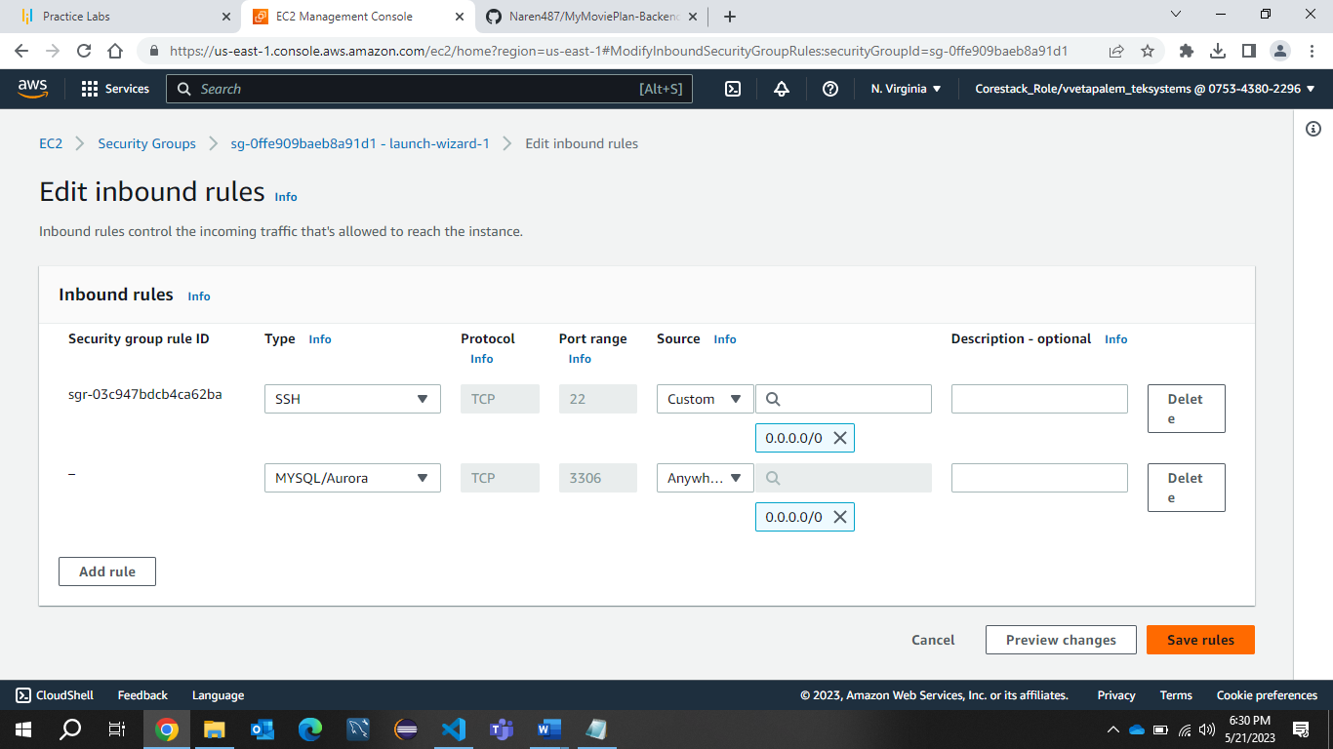

**Docker is iinstalled**

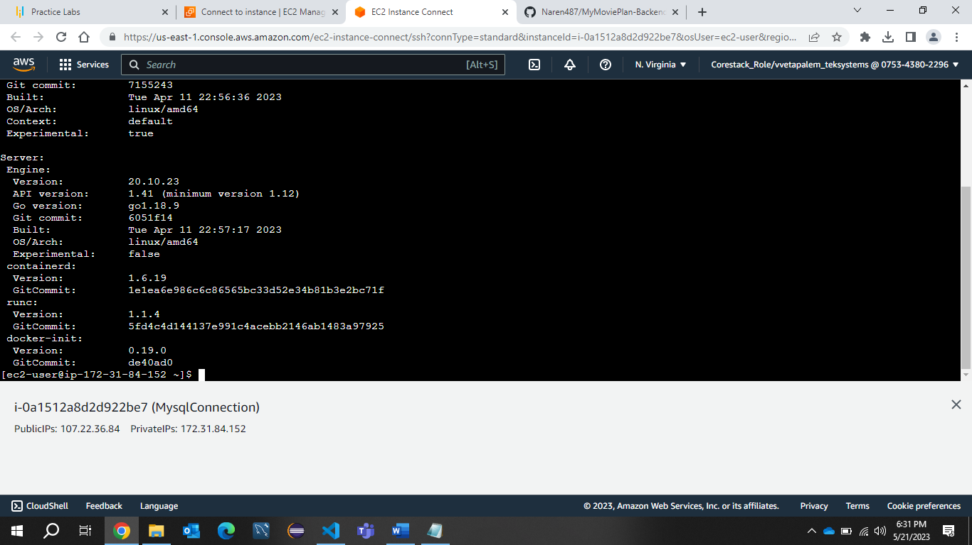

**Dockerized the mysql**

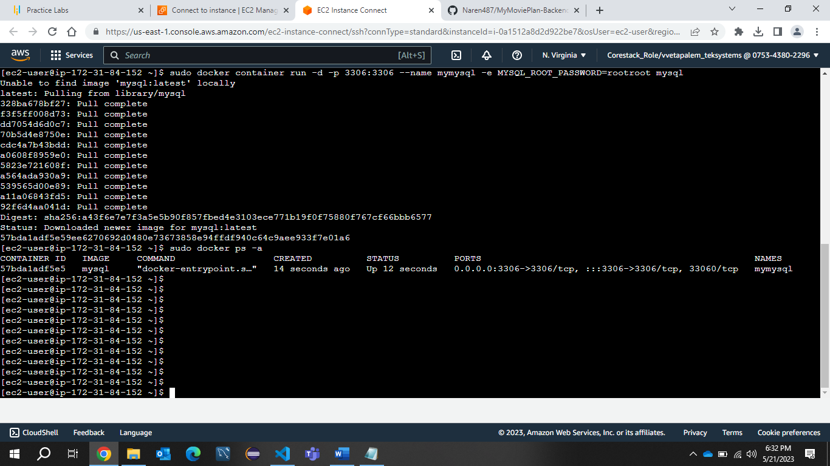

**successfully connected that mysql with my workbench**

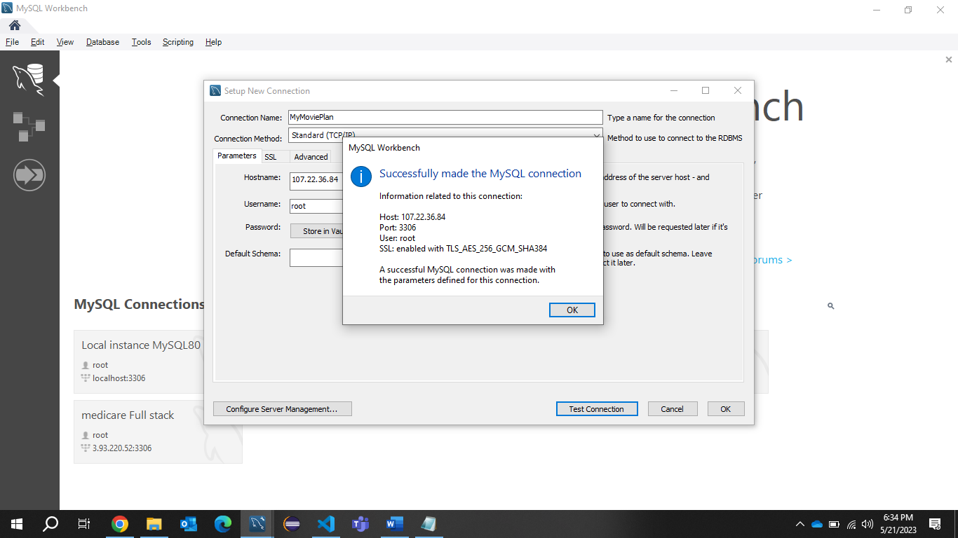

**Creating database mymovieplan**

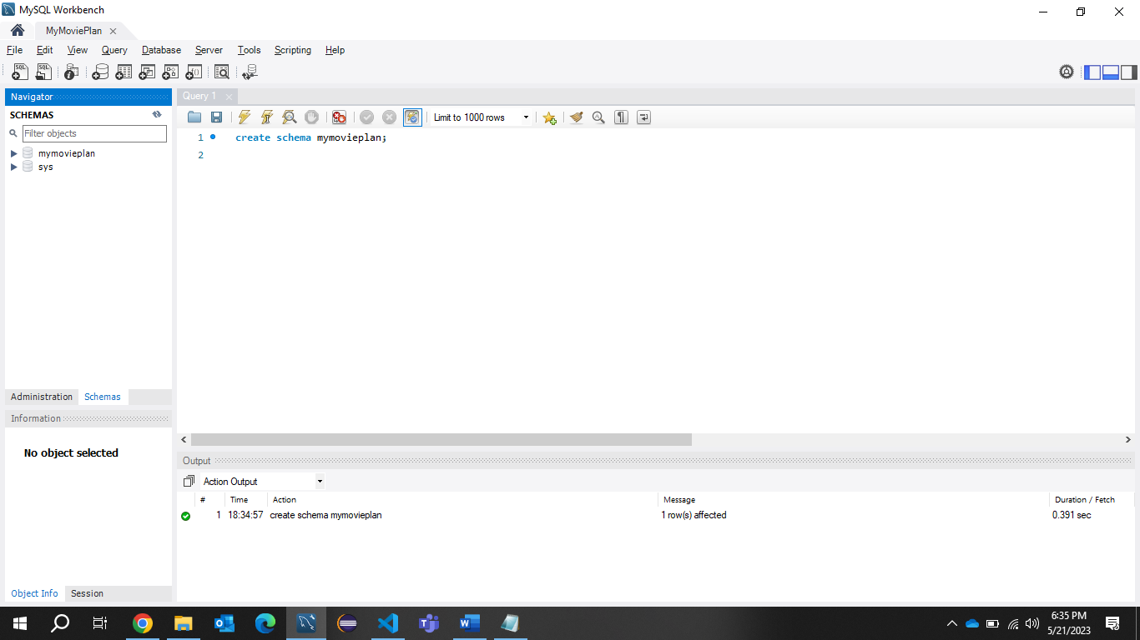

**Creating a new Instance for running MyMoviePlan FrontEnd and Backend Application**

**With java,git and Docker installed**

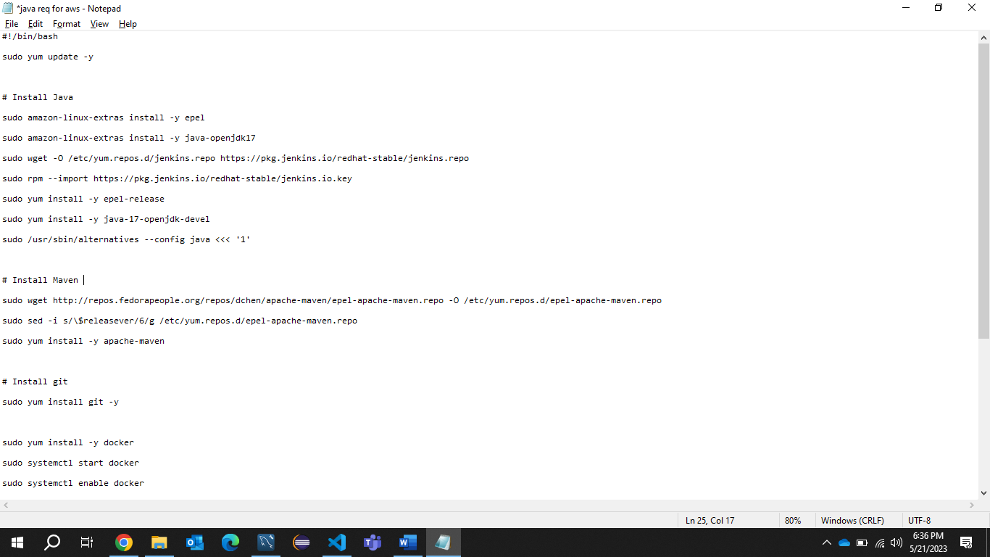

**Just had an issue with first one so created another instanc(MyMoviePlanApp)**

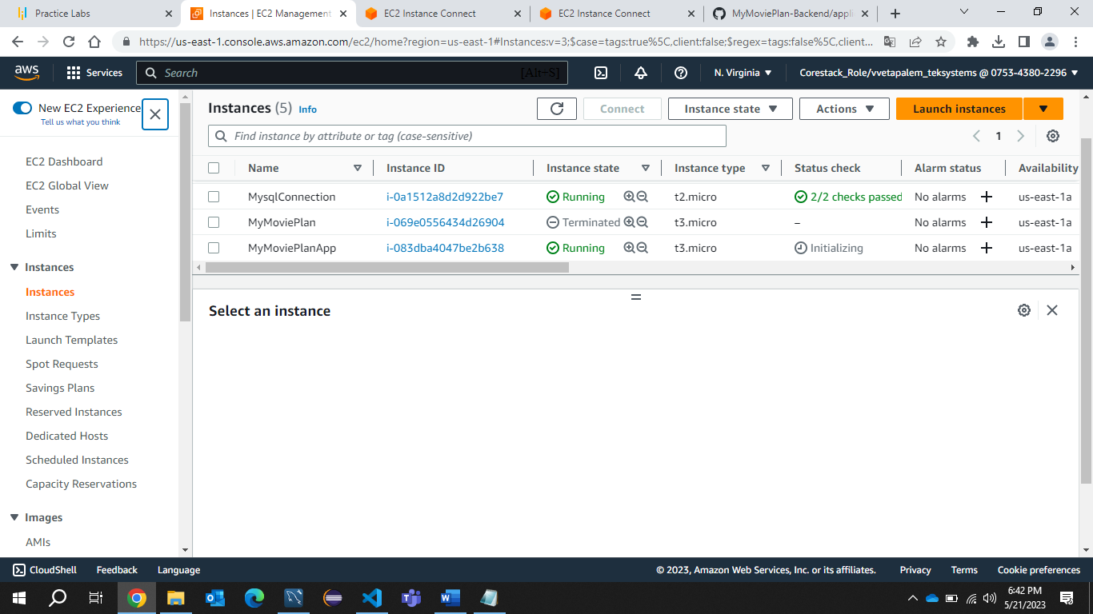

**I have already pushed my code in to github**

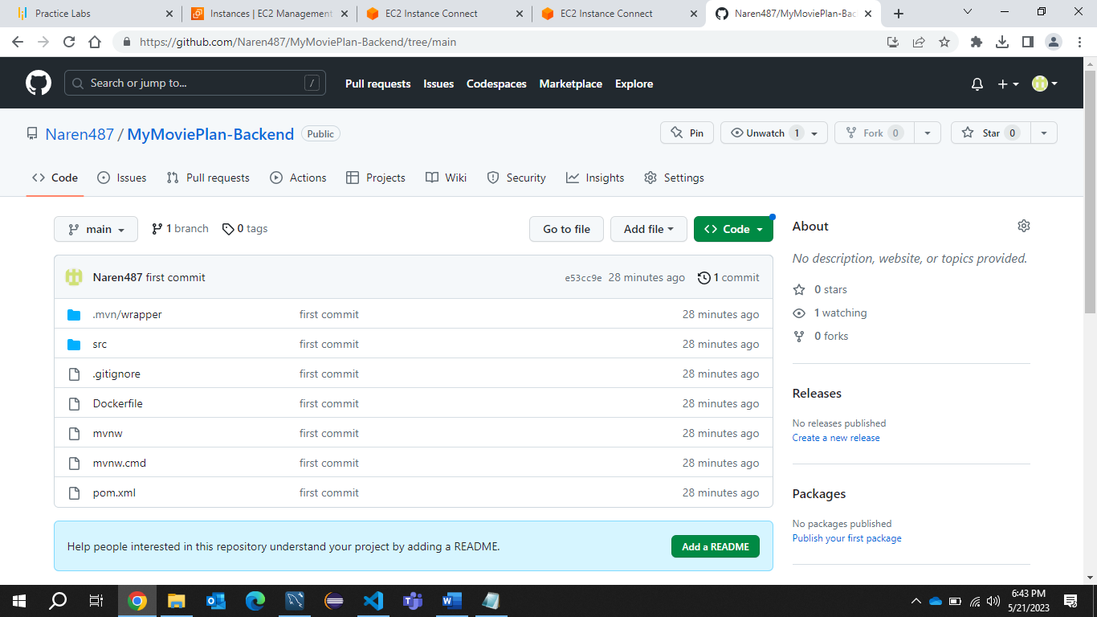

**This is the Dockerfile configuring mysql link here**

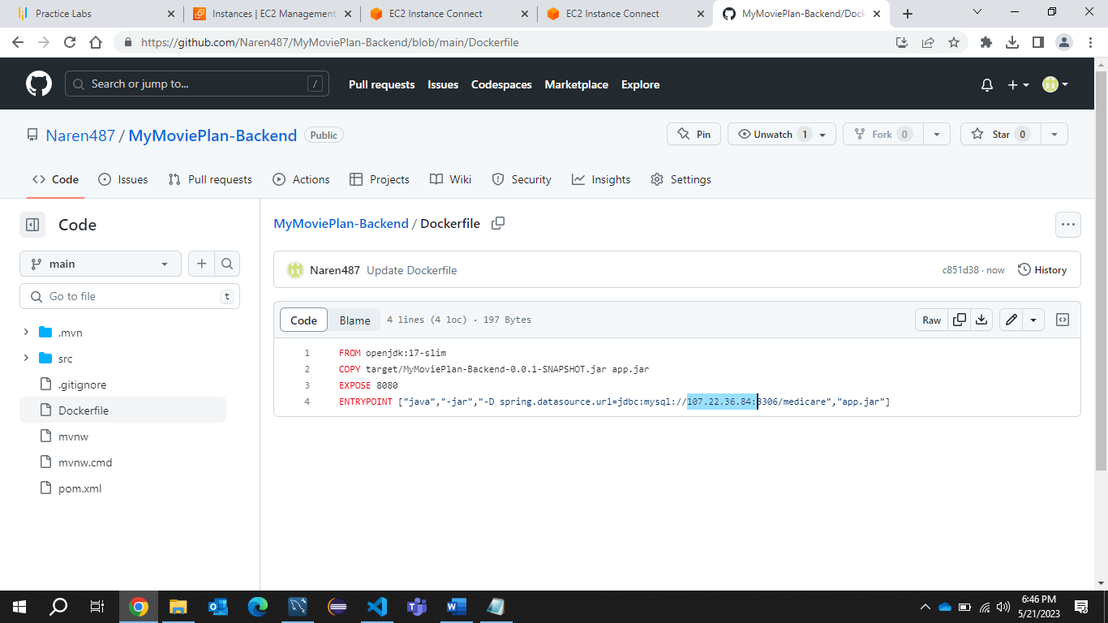

**Adding port 8080 for Backend Application**

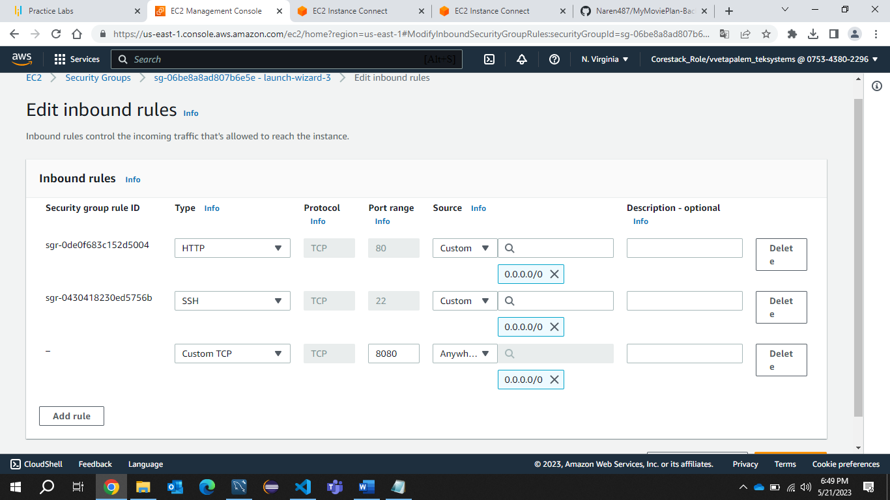

**Cloning the MyMoviePlan-Backed Repository**

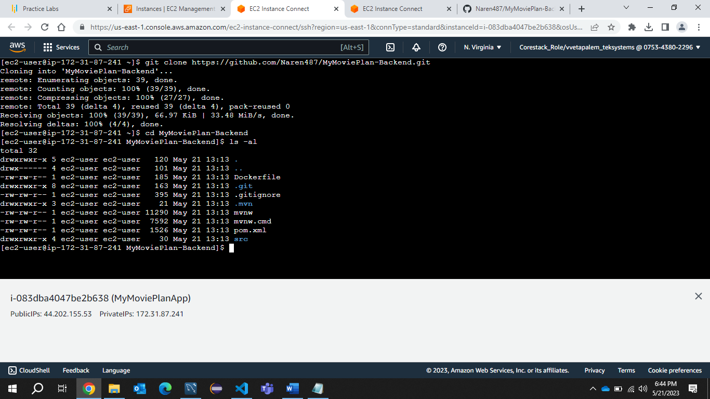

**Building the project using cmd mvn clean package**

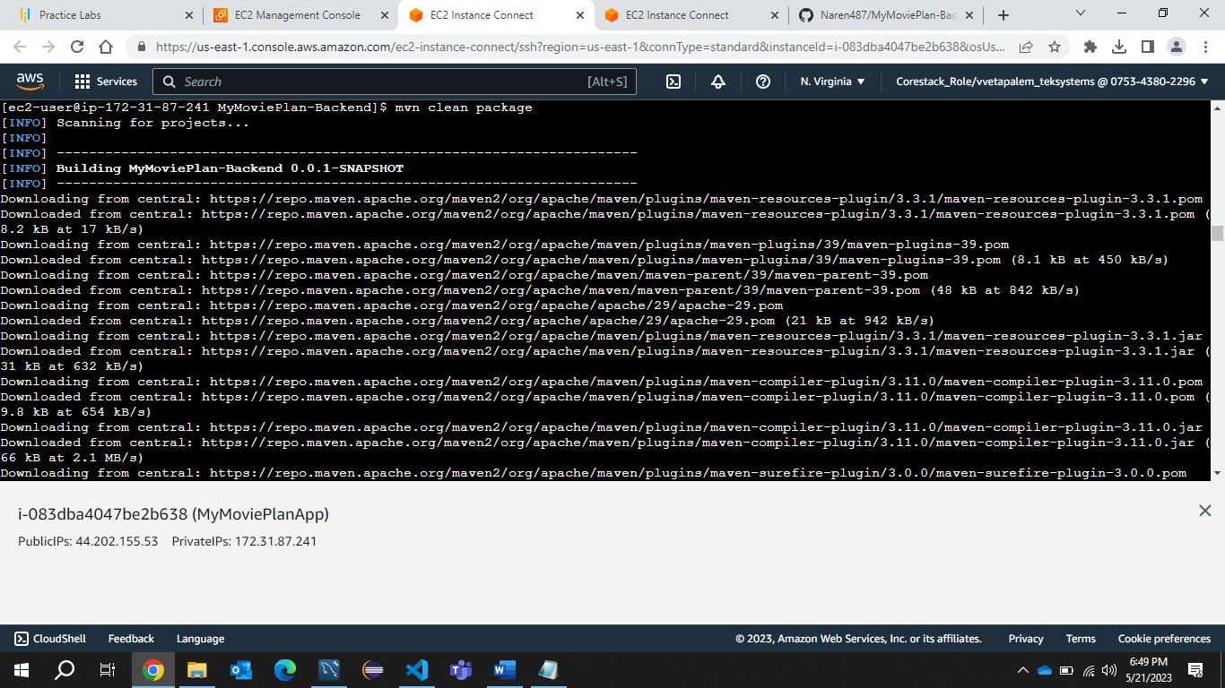

**Build Success**

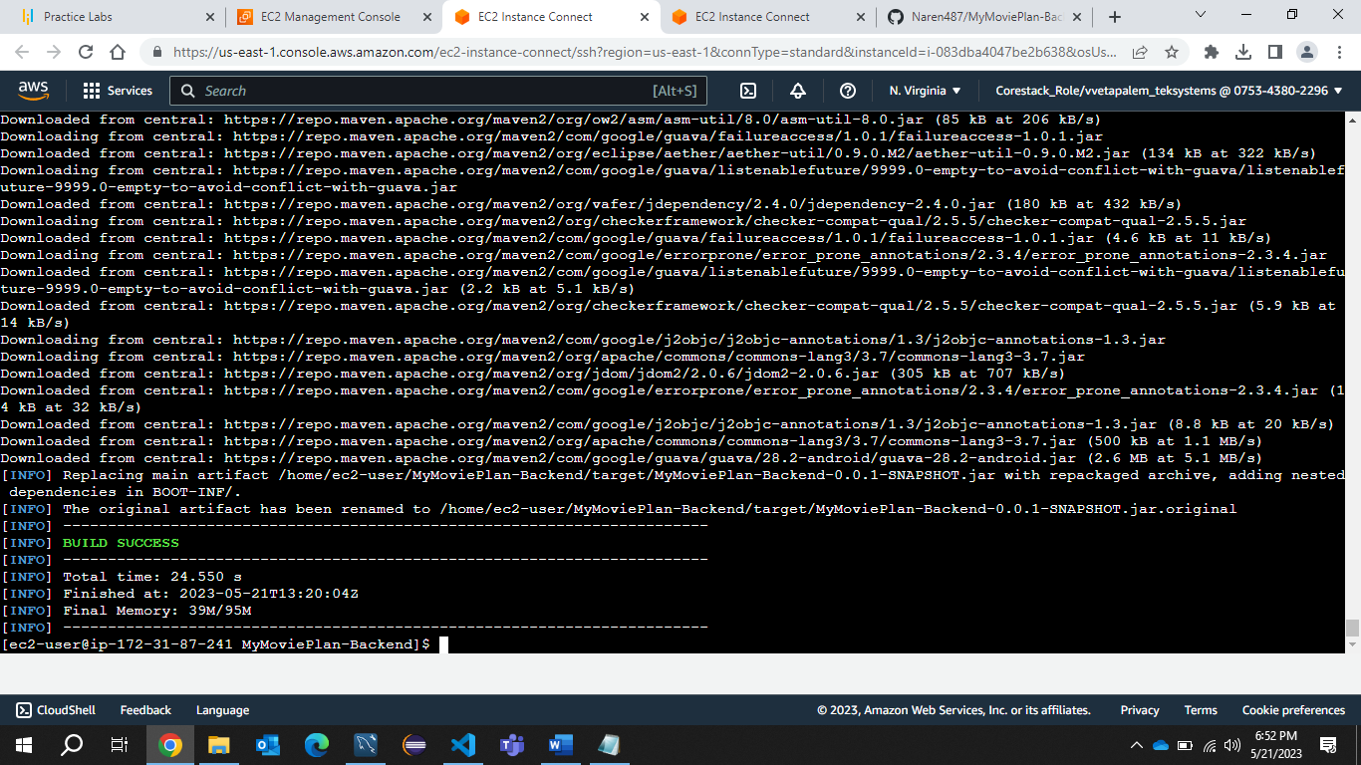

**Jar file is generated** 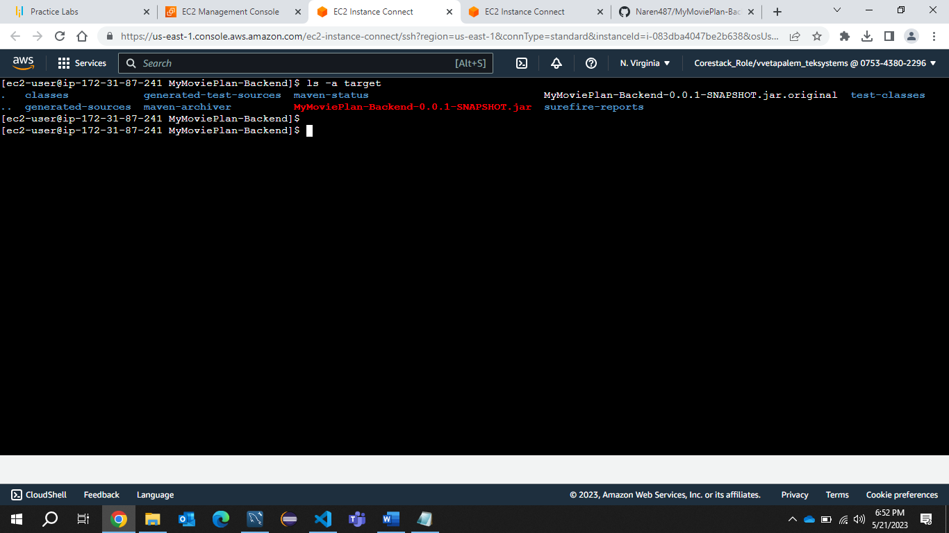

**Dockerizing the Backend application**

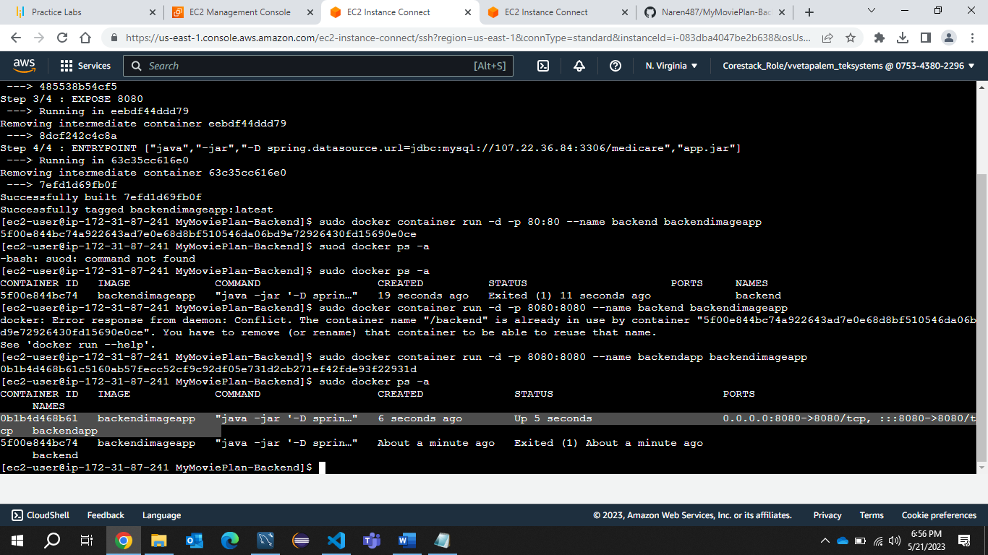

**This is the front end code which I have pushed to github**

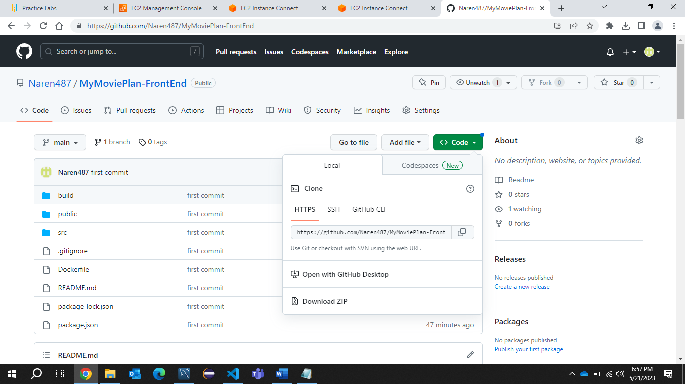

**Cloned the Mymovieplan-Frontend Application**

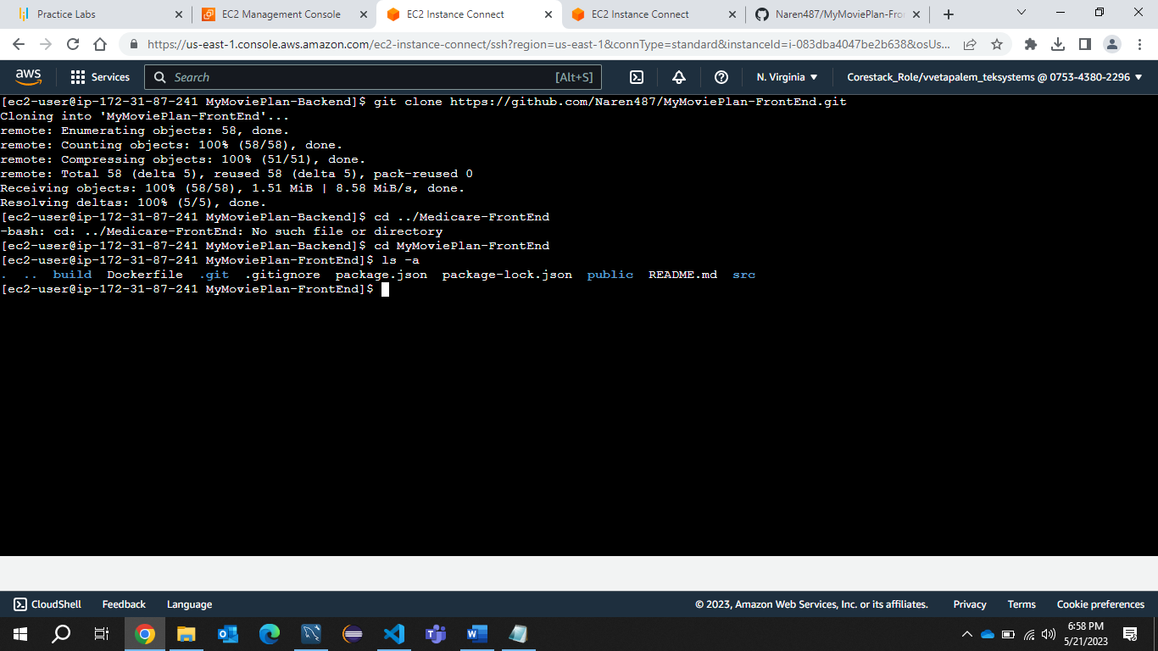

**Dockerizing the MyMovieplan-FrontEnd Application**

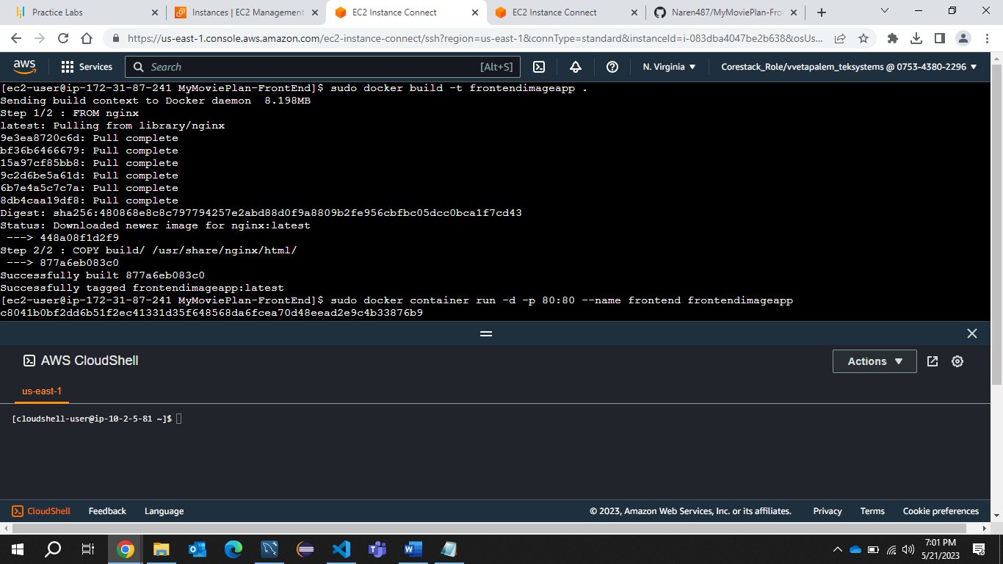

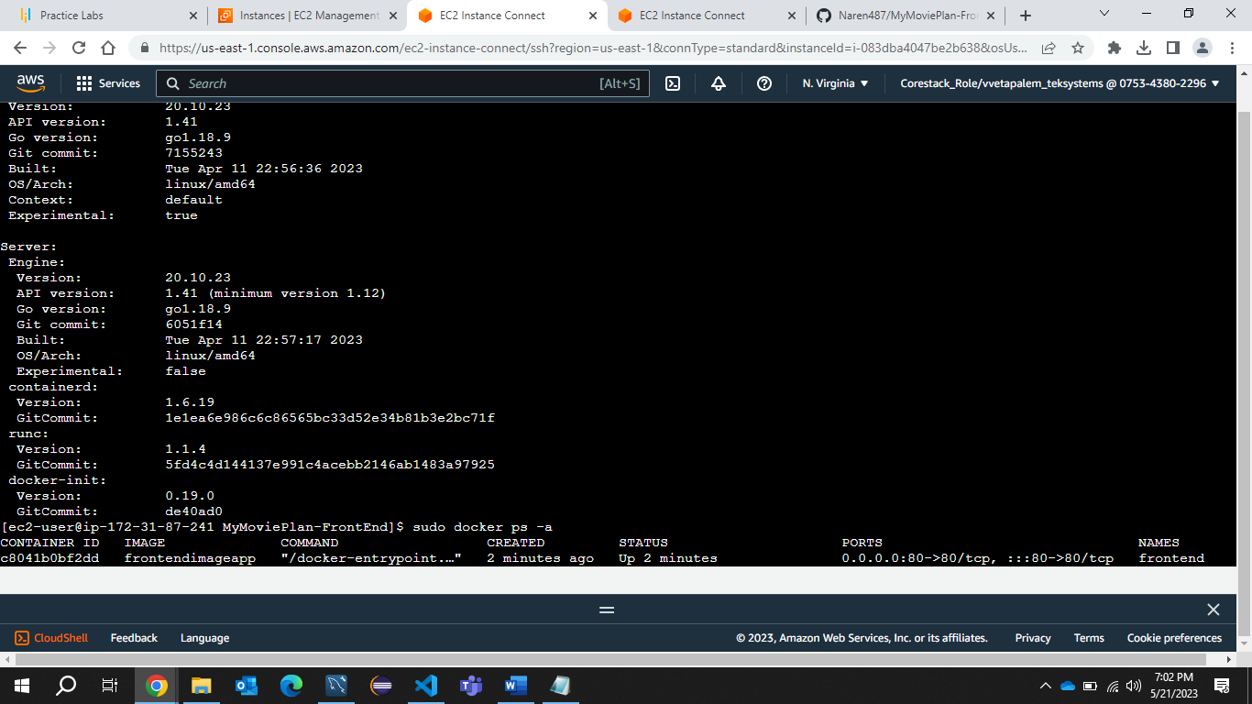

**Successfully Deployed the application in the EC2 instance**

 